Welcome to AMJA’s Sale Barn. If you have something you’d like listed
send us pictures of the Cow/Calf/Bull and pertinent information along
with location, price and your contact info! We would every ad to at
least include the animal for sale and a udder shot of his/or hers dam.
Thanks you for visiting the Sale Barn! (Scroll down)

Jewel’s Little Nobleman A2A2, Hetro polled and 41” tall
out of Rocking Robins Noble Duke x Jersey Knoll JKH Lucy
This boy is ready to go to work !!!
Owner Sara Haas located in Gering NE, USA 308-436-1754 home / 303-931-9950
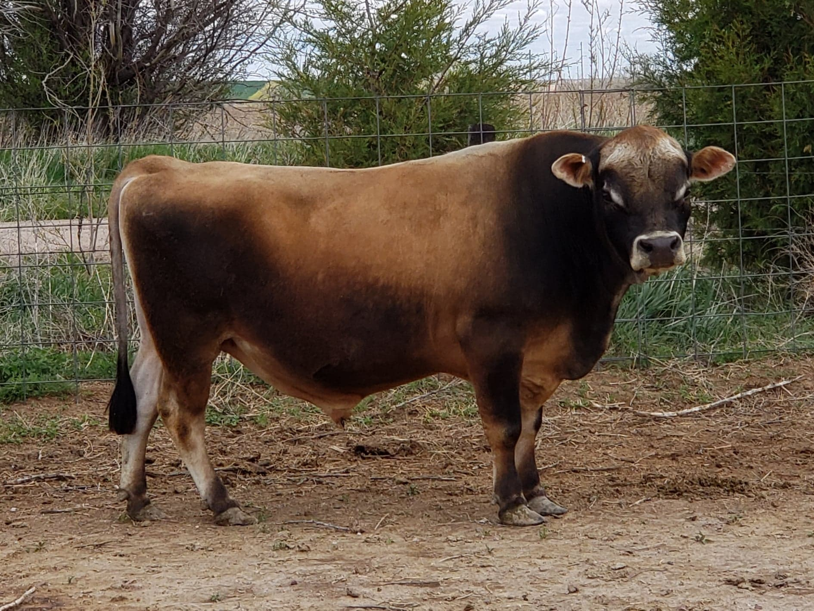
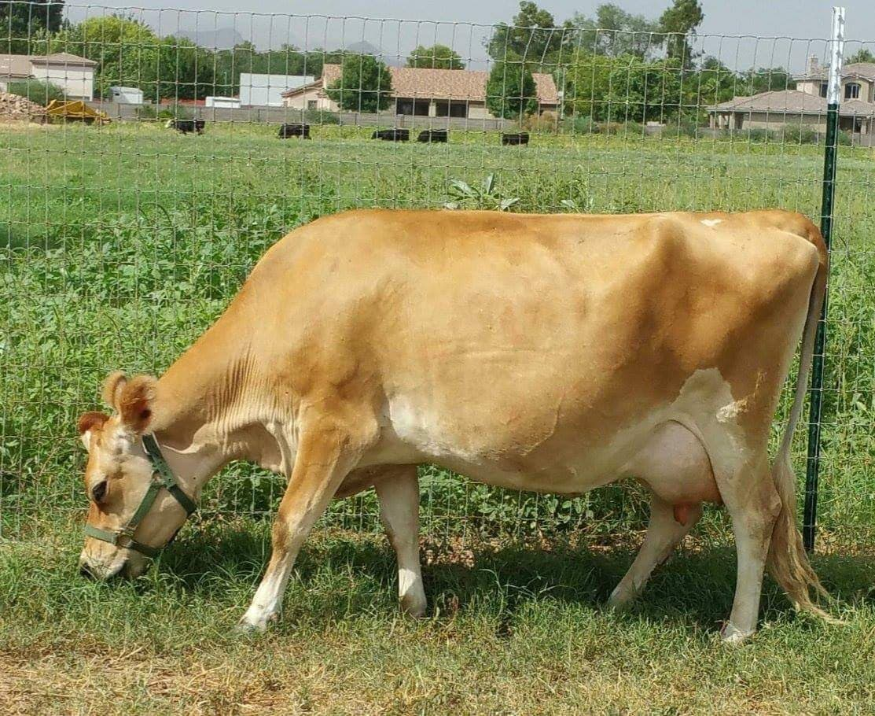

OakCreekminiJerseys. com Location: Ellsworth, Ks cjanssen383@gmail.com “Hondo” Bull calf
out of DC Taylors Alpha and Beeson’s Cupcake born 4/15/19 A1A2 (A2B), Polled and 24” at birth.
Awesome Milk genetics behind this little guy. Owner: Cindy Janssen asking $1500 785-531-0224
